**Note: For all experiments circuit diagram, calculation must be copies from observation and waveforms must be done in graph sheet**

1. **Design an astable multivibrator circuit for three cases of duty cycle (50%, 50%) using NE 555 timer IC. Simulate the same for any one duty cycle.**

**COMPONENTS REQUIRED**: 555 Timer IC, Resistors of 3.3KΩ, 6.8KΩ, Capacitors of 0.1 μF, 0.01 μF, Regulated power supply, CRO.

**DESIGN** : Given frequency (f) = 1KHz and duty cycle = 60% (=0.6)

The time period T =1/f = 1ms = Ton + Toff

Where Ton is the time the output is high and Toff  is the time the output is low.

From the theory of astable multivibrator using 555 Timer(refer Malvino), we have

Ton = 0.693 RB C ------(1)

Toff = 0.693 (RA + RB)C ------(2)

T = Ton + Toff  = 0.693 (RA +2 RB) C

Duty cycle = Ton / T = 0.6. Hence Ton = 0.6T = 0.6ms and Toff = T – TC = 0.4ms.

Let C=0.1μF and substituting in the above equations,

RB = 5.8KΩ (from equation 1) and RA = 2.9KΩ (from equation 2 & RB values).

The Vcc determines the upper and lower threshold voltages (observed from the capacitor voltage waveform) as .

Note: The duty cycle determined by RA & RB can vary only between 50 & 100%. If RA is much smaller than RB, the duty cycle approaches 50%.

Example 2: frequency = 1kHz and duty cycle =75%, RA = 7.2kΩ & RB =3.6kΩ, choose RA = 6.8kΩ and RB = 3.3kΩ.

**PROCEDURE** :

1. Before making the connections, check the components using multimeter.
2. Make the connections as shown in figure and switch on the power supply.
3. Observe the capacitor voltage waveform at 6th pin of 555 timer on CRO.
4. Observe the output waveform at 3rd pin of 555 timer on CRO (shown below).
5. Note down the amplitude levels, time period and hence calculate duty cycle.

**THEORY:**

Multivibrator is a form of oscillator, which has a non-sinusoidal output. The output waveform is rectangular. The multivibrators are classified as: **Astable or free running multivibrator**: It alternates automatically between two states (low and high for a rectangular output) and remains in each state for a time dependent upon the circuit constants. It is just an oscillator as it requires no external pulse for its operation. **Monostable or one shot multivibrator**: It has one stable state and one quasi stable. The application of an input pulse triggers the circuit time constants. After a period of time determined by the time constant, the circuit returns to its initial stable state. The process is repeated upon the application of each trigger pulse. **Bistable Multivibrators**: It has both stable states. It requires the application of an external triggering pulse to change the output from one state to other. After the output has changed its state, it remains in that state until the application of next trigger pulse. Flip flop is an example.

**RESULT**:

The frequency of the oscillations = ………….Hz.

1. **Using ua 741 Opamp, design a 1 kHz Relaxation Oscillator with 50% duty cycle. And simulate the same.**

**COMPONENTS REQUIRED**:

Op-amp μA 741, Resistor of 1KΩ, 10KΩ, 20 kΩ Potentiometer, Capacitor of 0.1 μF, Regulated DC power supply, CRO

**DESIGN :**

The period of the output rectangular wave isgiven as ****-------(1)

Where,  is the feedback fraction

If R1 = R2, then from equation (1) we have T = 2RC ln(3)

Another example, if R2=1.16 R1, then T = 2RC ----------(2)

Example: Design for a frequency of 1kHz (implies )

Use R2=1.16 R1, for equation (2) to be applied.

Let R1 = 10kΩ, then R2 = 11.6kΩ (use 20kΩ potentiometer as shown in circuit figure)

Choose next a value of C and then calculate value of R from equation (2).

Let C=0.1µF (i.e., 10-7), then 

The voltage across the capacitor has a peak voltage of 

**PROCEDURE :**

1. Before making the connections check all the components using multimeter.
2. Make the connections as shown in figure and switch on the power supply.
3. Observe the voltage waveform across the capacitor on CRO.
4. Also observe the output waveform on CRO. Measure its amplitude and frequency.

**THEORY:**

Op-Amp Relaxation Oscillator is a simple Square wave generator which is also called as a Free running oscillator or Astable multivibrator or Relaxation oscillator. In this figure the op-amp operates in the saturation region. Here, a fraction (R2/(R1+R2)) of output is fed back to the noninverting input terminal. Thus reference voltage is (R2/(R1+R2)) Vo. And may take values as +(R2/(R1+R2)) Vsat or - (R2/(R1+R2)) Vsat. The output is also fed back to the inverting input terminal after integrating by means of a low-pass RC combination. Thus whenever the voltage at inverting input terminal just exceeds reference voltage, switching takes place resulting in a square wave output.

**RESULT**:

The frequency of the oscillations = …………Hz.

1. **Using ua 741 opamap, design a window comparator for any given UTP and LTP. And simulate the same**

**COMPONENTS REQUIRED** : IC μA 741, Resistor of 10KΩ, 90KΩ, DC regulated power supply, Signal generator, CRO

**DESIGN 1** :

From theory of Schmitt trigger circuit using op-amp, we have the trip points,

 **DESIGN 2** :

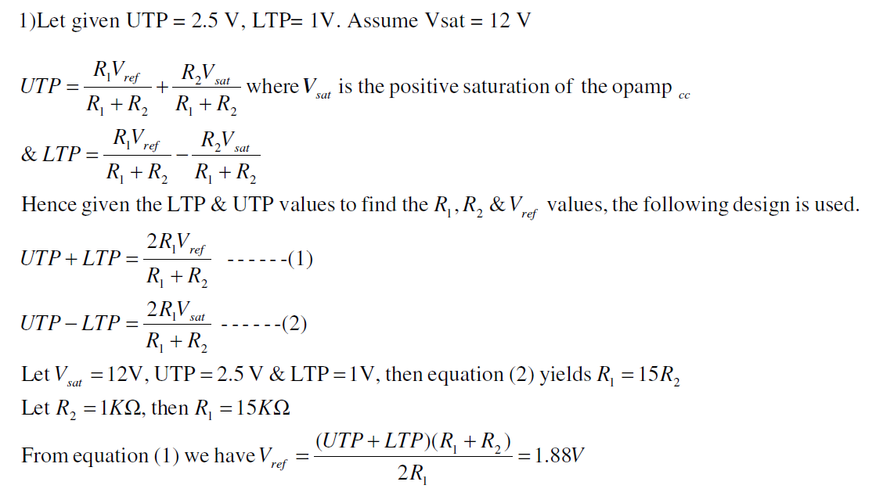

**PROCEDURE** :

1. Before doing the connections, check all the components using multimeter.
2. Make the connection as shown in circuit diagram.
3. Using a signal generator apply the sinusoidal input waveform of peak-to-peak amplitude of 10V, frequency 1kHz.
4. Keep the CRO in dual mode; apply input (Vin) signal to the channel 1 and observe the output (Vo) on channel 2 which is as shown in the waveform below. Note the amplitude levels from the waveforms.
5. Now keep CRO in X-Y mode and observe the hysteresis curve.

**Theory**

Window Comparator

* A comparator is a circuit which compares a signal voltage applied at one input of an op-amp with a known reference voltage at the other input.

* A window comparator is basically the inverting and the non-inverting comparators, combined into a single comparator stage. The window comparator detects input voltage levels that are within a specific band or window of voltages, instead of indicating whether a voltage is greater or less than some preset or fixed voltage reference point.

* In window comparator, the output changes state when the input voltage goes above or below the reset reference voltage. In a window comparator, there are two reference voltages, called lower and upper trip points (UTP & LTP). Output is in one state, when it is inside the window created by the lower and the upper trip points and in the other state when it is outside the window.

**Result:---------------------------------------**